**Primary Bank Account Details**

**Name:** Nathishma Nadarajan

**Bank Name:** Indian Overseas Bank

**Account no:** 104301000038126

**IFSC Code:** IOBA0001043

**Bank Branch:** Vetturnimadam

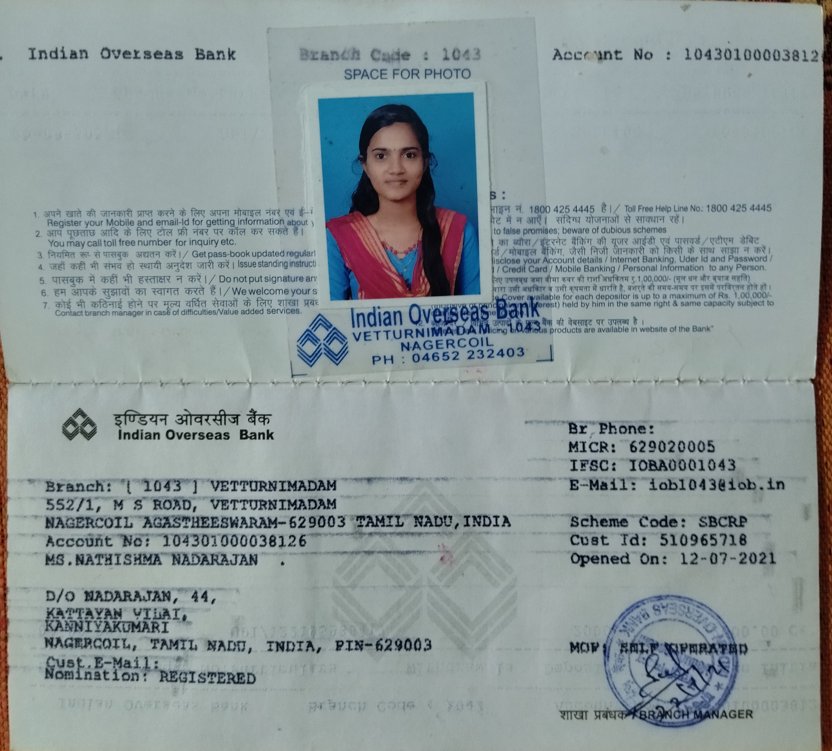

**Secondary Bank Account Details**

**Name:** Nathishma N

**Bank Name:** State Bank of India

**Account no:** 20273953065

**IFSC Code:** SBIN0012757

**Bank Branch:** Parvathipuram

